[Date]

Kyer Potts

30003389

Database Programming AT3

Report

Table of Contents

Testing 1

Screenshot 1 3

Screenshot 2.1 3

Screenshot 2.2 4

Screenshot 3.1 4

Screenshot 3.2 5

Screenshot 3.3 5

Screenshot 3.4 6

Screenshot 3.5 6

Screenshot 3.6 7

Screenshot 4.1 7

Screenshot 4.2 8

Screenshot 5.1 8

Screenshot 5.2 9

Screenshot 5.3 9

Screenshot 5.4 10

Screenshot 6.1 10

Screenshot 6.2 11

Screenshot 6.3 11

Security 12

Recommendations 13

# Testing

|  |  |  |  |
| --- | --- | --- | --- |
| Test ID | Description | Outcome | Evidence |
| 1 | Home Page Opens | Home Page displayed correctly | Refer to screenshot 1 |
| 2.1 | Suppliers Page Opens | Suppliers Page displays correct information | Refer to screenshot 2.1 |
| 2.2 | Products by suppliers opens | Page displays correct information to dropdown selection | Refer to screenshot 2.2 |
| 3.1 | Products Page Open | Product Page displays correct information | Refer to screenshot 3.1 |
| 3.2 | Products dropdown selection opens product description page | Product description page opens and displays correct and relevant information | Refer to screenshot 3.2 |
| 3.3 | Products by Category Page opens | Products by category page opens successfully | Refer to screenshot 3.3 |
| 3.4 | Products by category dropdown selection opens product by category description page | Products by category description page open successfully and displays correct and relevant information | Refer to screenshot 3.4 |
| 3.5 | Products by supplier page opens | Products by supplier page opens successfully | Refer to screenshot 3.5 |
| 3.6 | Products by supplier dropdown selection opens product by category description page | Products by supplier page opens successfully and displays correct and relevant information | Refer to screenshot 3.6 |
| 4.1 | Invoices page opens | Invoices page opens successfully and displays correct dropdown selection | Refer to screenshot 4.1 |
| 4.2 | Invoice dropdown selection opens correct page | Invoice dropdown selection functions correctly and opens page to relevant selected invoice | Refer to screenshot 4.2 |
| 5.1 | Customers page opens | Customers page opens successfully and displays dropdown selection box | Refer to screenshot 5.1 |
| 5.2 | Customer dropdown selection opens correct page | Correct page is opened and displays all relevant information including Invoices | Refer to screenshot 5.2 |
| 5.3 | Add new Customer opens | Add new customer page opens successfully and displays all relevant fields for input | Refer to screenshot 5.3 |
| 5.4 | Customer fields insert into database | Fields successfully inserted into database, displays “success” message | Refer to screenshot 5.4 |
| 6.1 | Employees page opens | Employees page opens successfully. Dropdown selection displays all available employees | Refer to screenshot 6.1 |
| 6.2 | Dropdown selection opens invoices by employee page | Invoice by employee page opens successfully and displays all invoices in dropdown selection | Refer to screenshot 6.2 |
| 6.3 | Update Employee Details page | Update employee details page opens successfully and displays all relevant fields for update | Refer to screenshot 6.3 |

## Screenshot 1

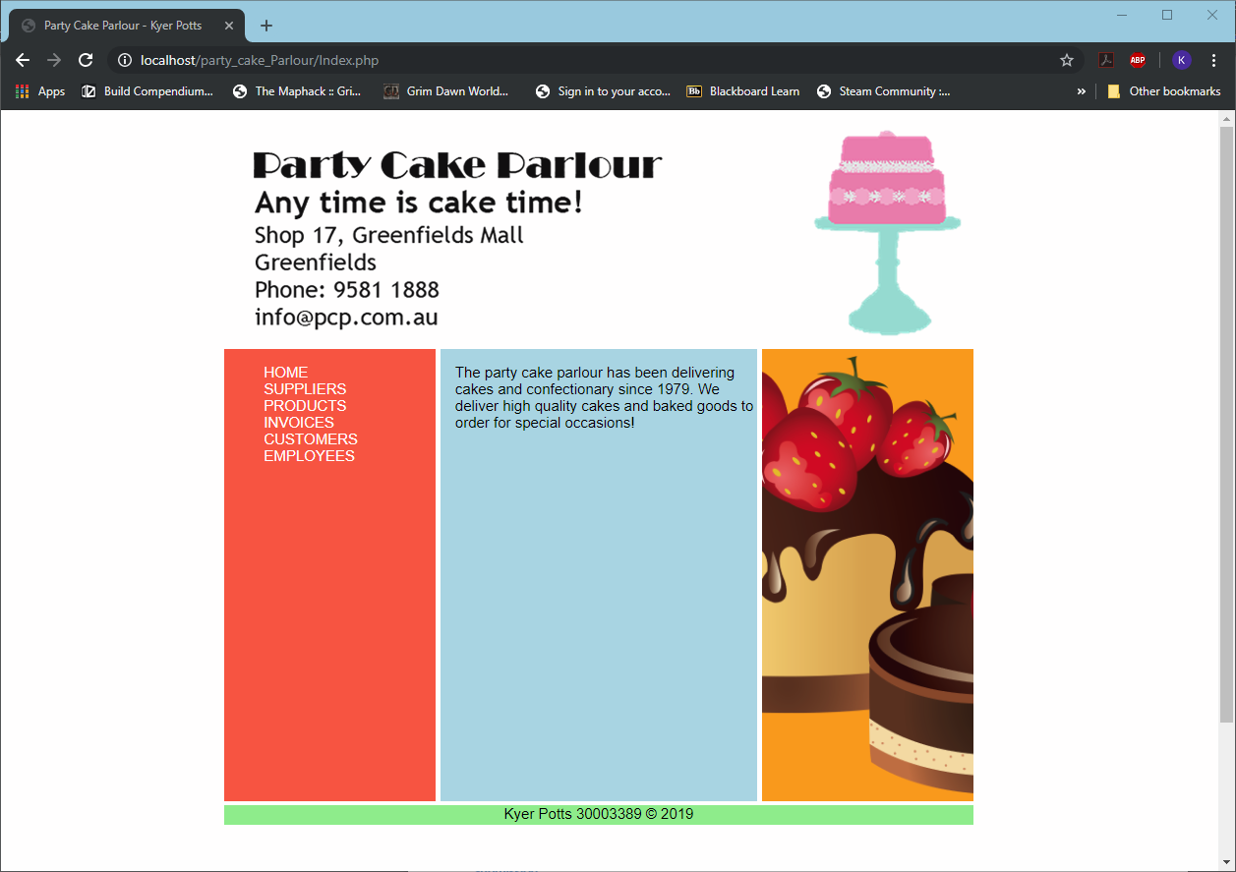

## Screenshot 2.1

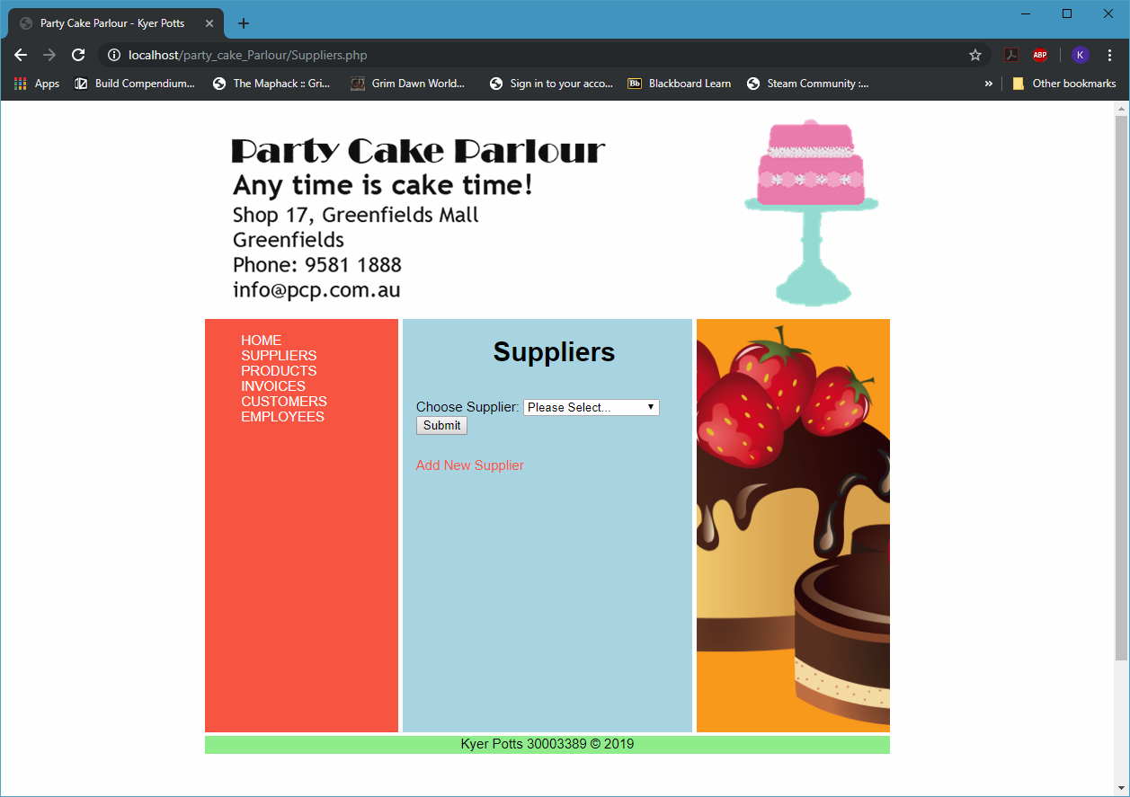

## Screenshot 2.2

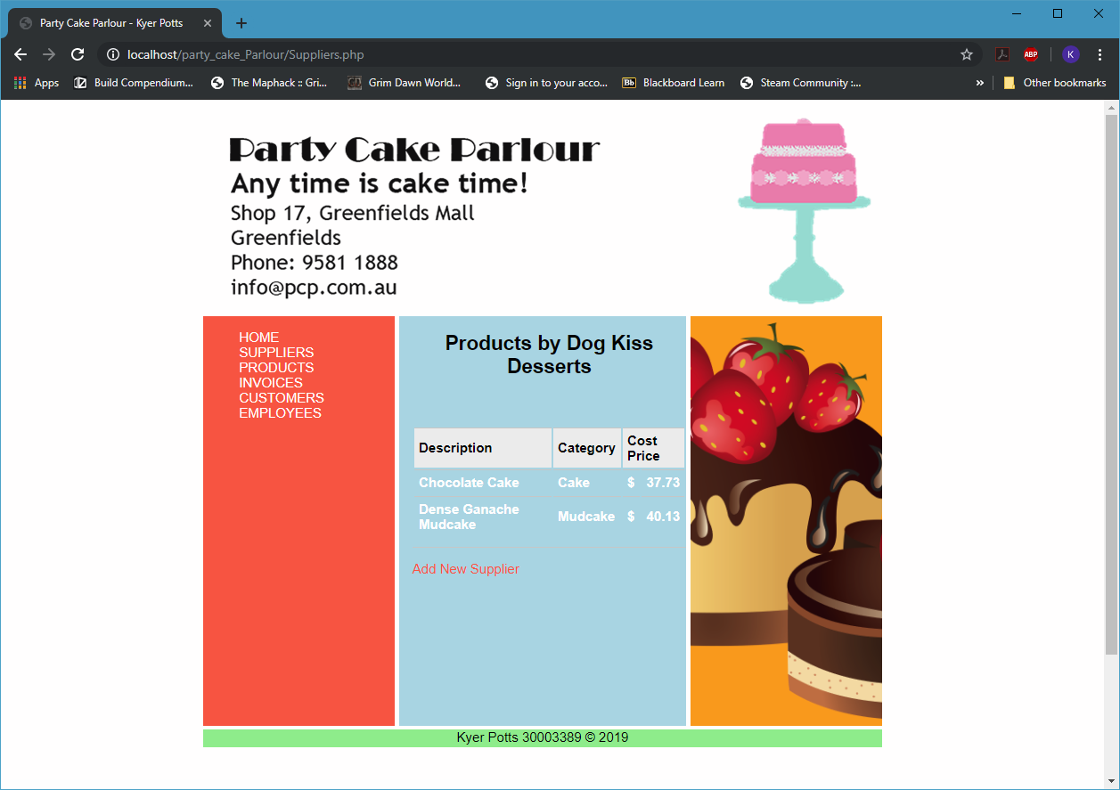

## Screenshot 3.1

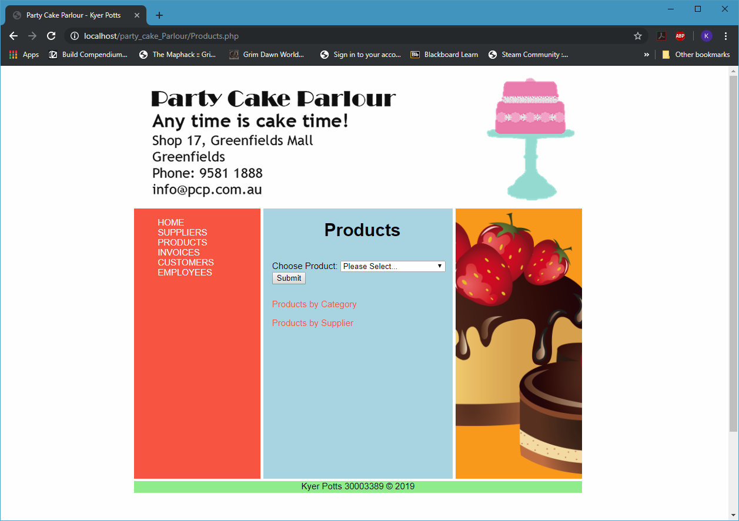

## Screenshot 3.2

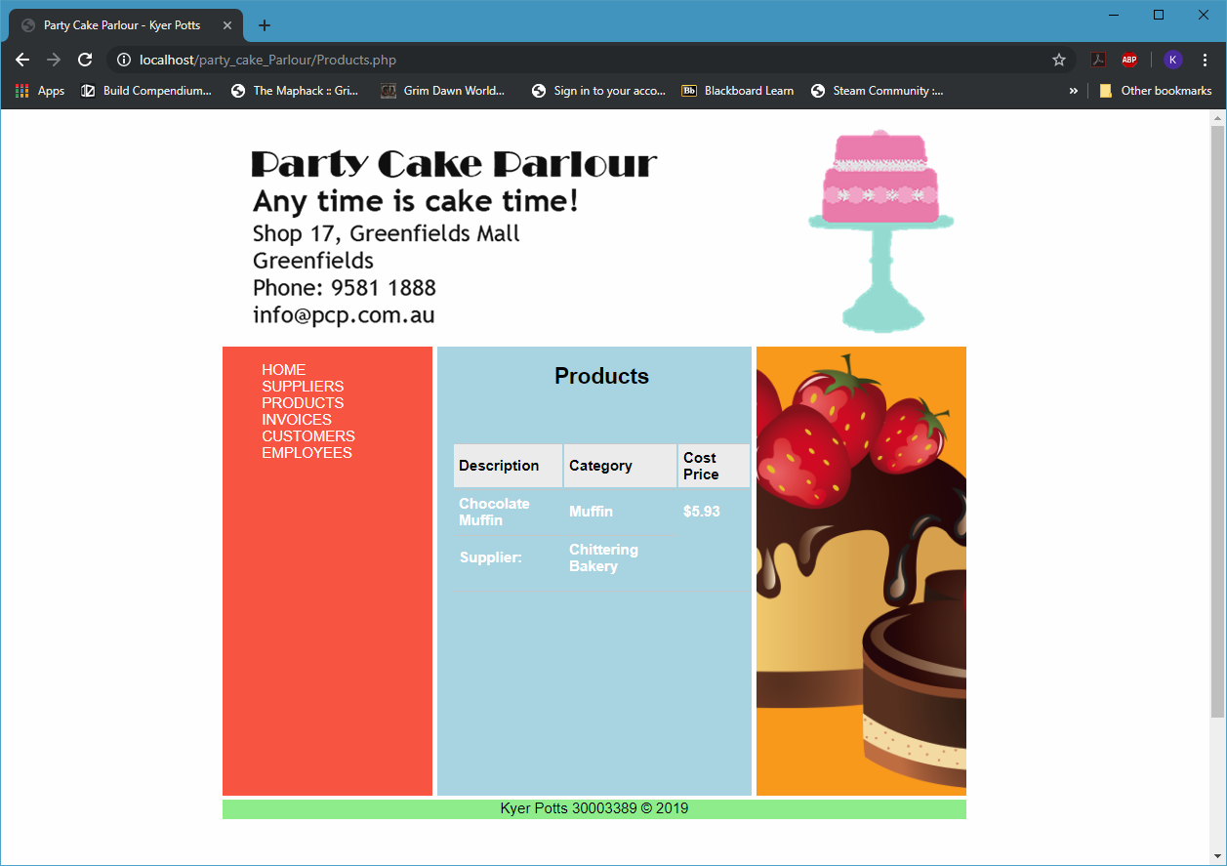

## Screenshot 3.3

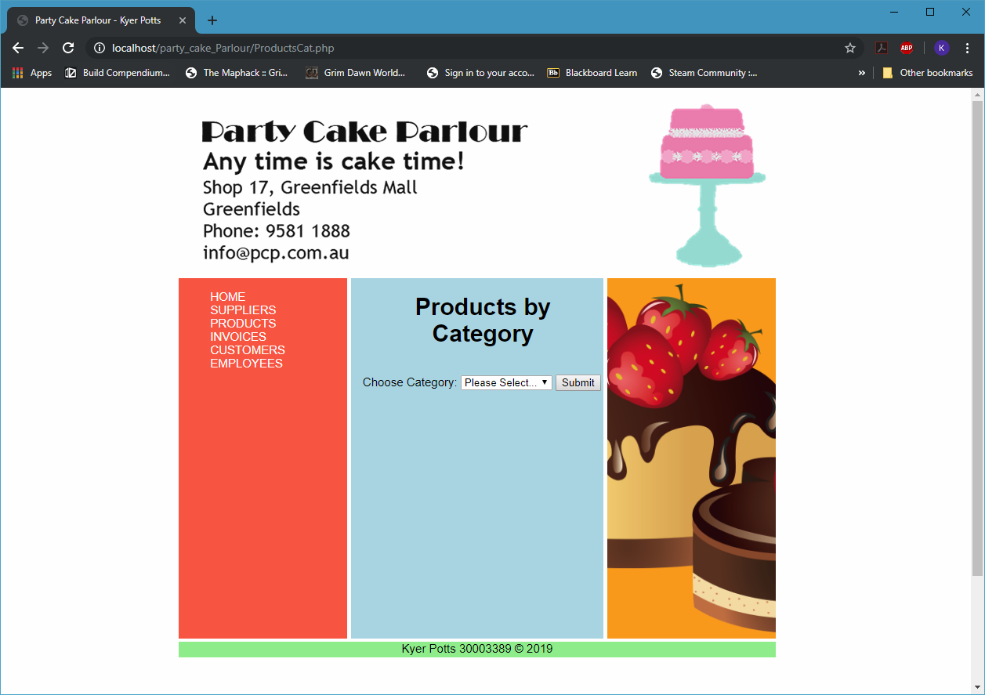

## Screenshot 3.4

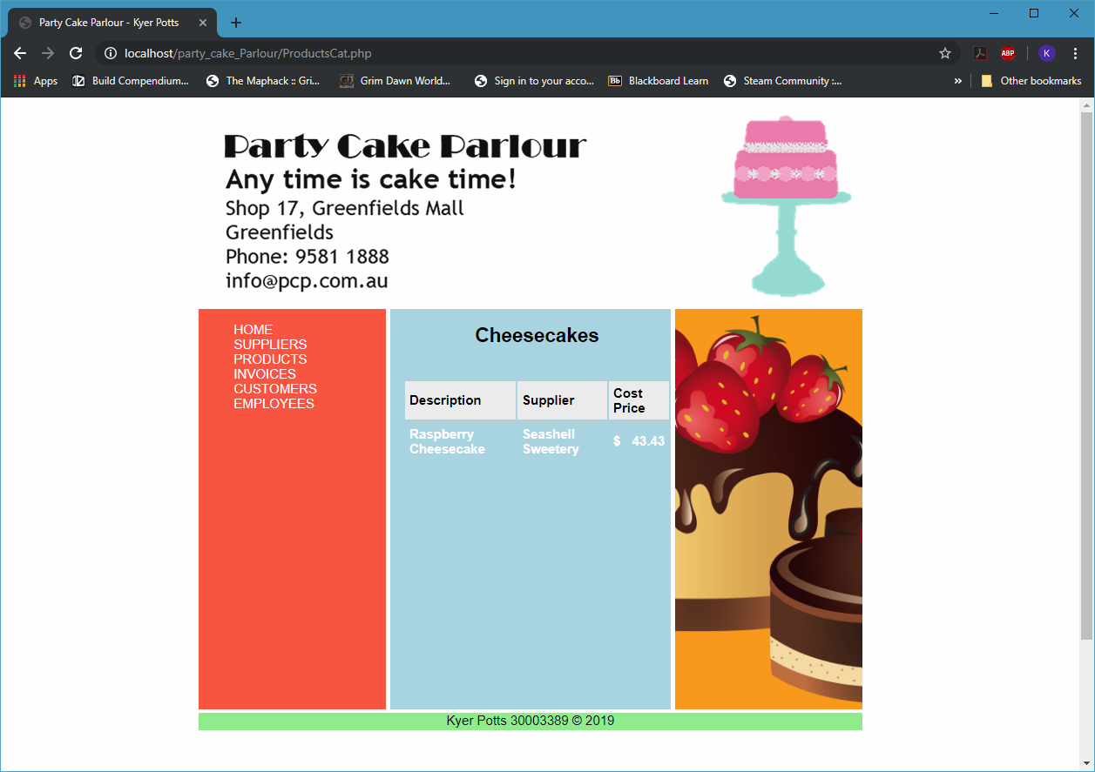

## Screenshot 3.5

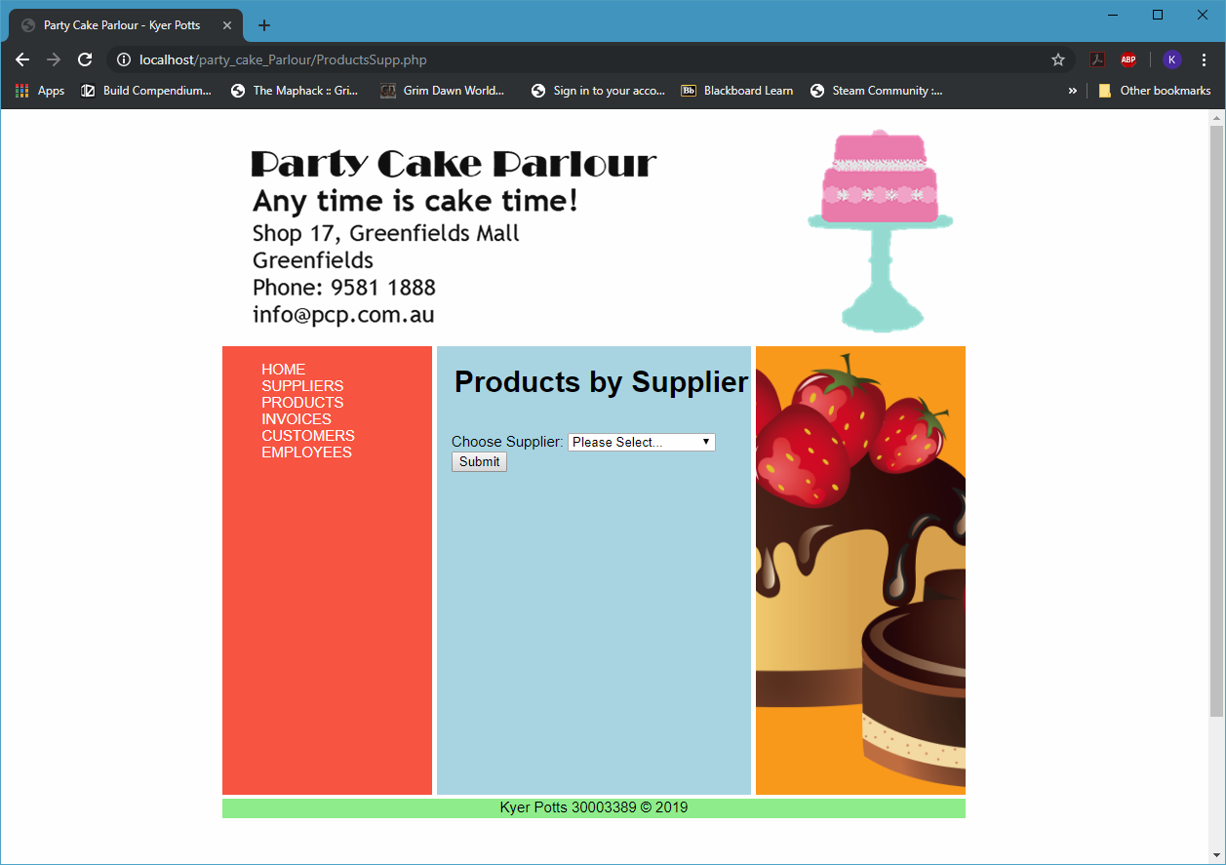

## Screenshot 3.6

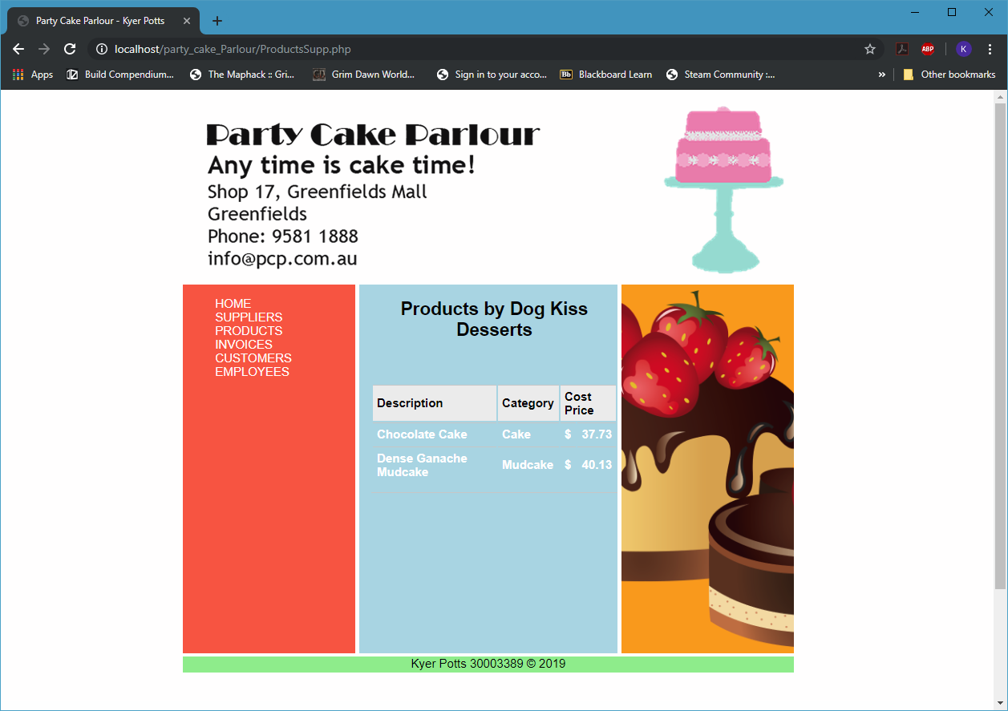

## Screenshot 4.1

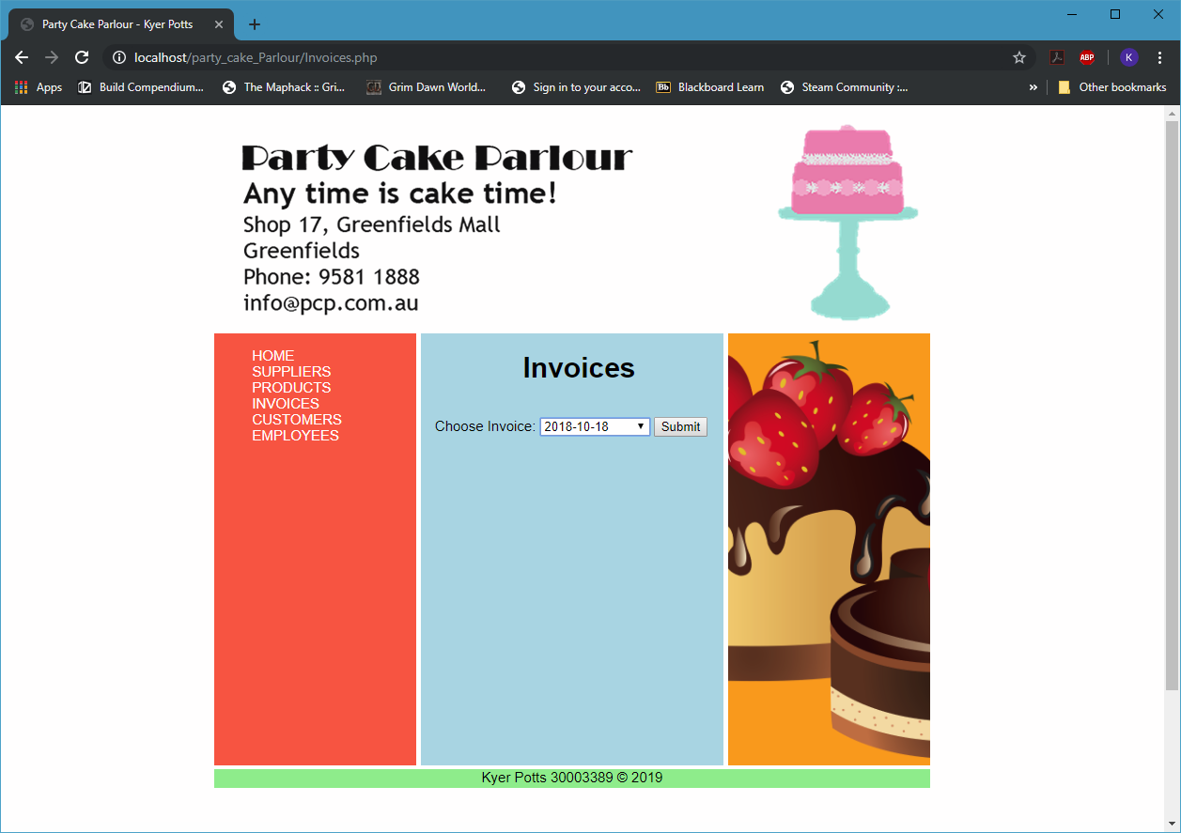

## Screenshot 4.2

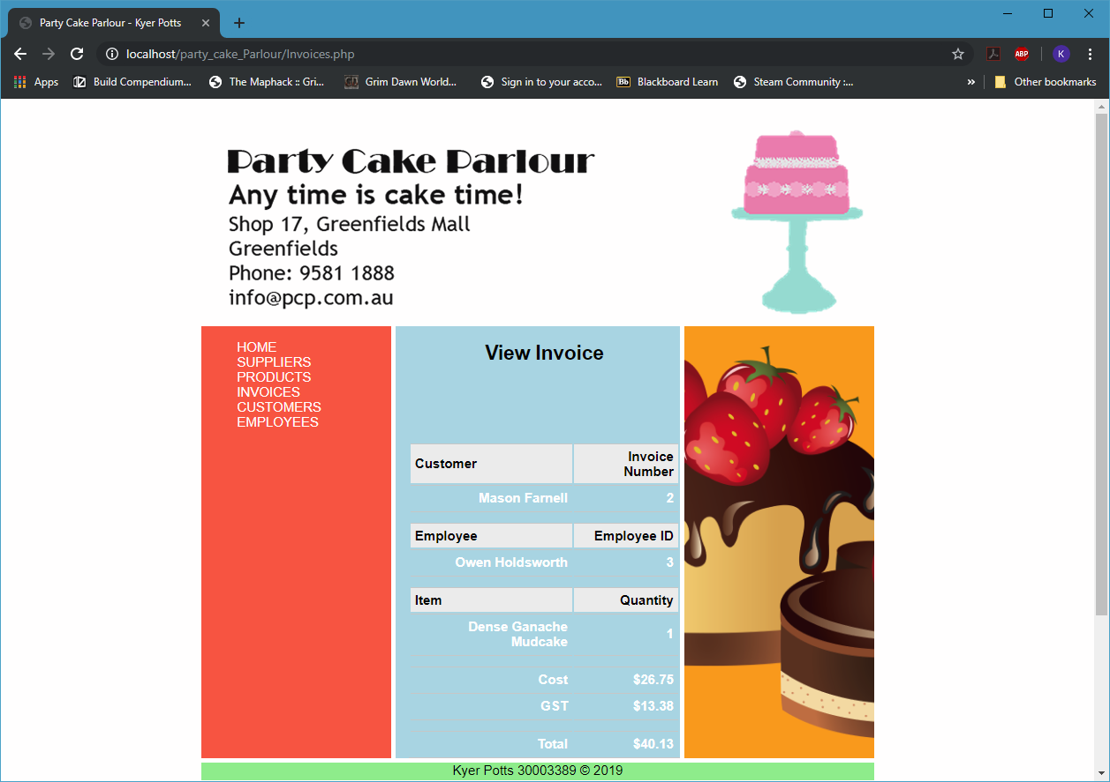

## Screenshot 5.1

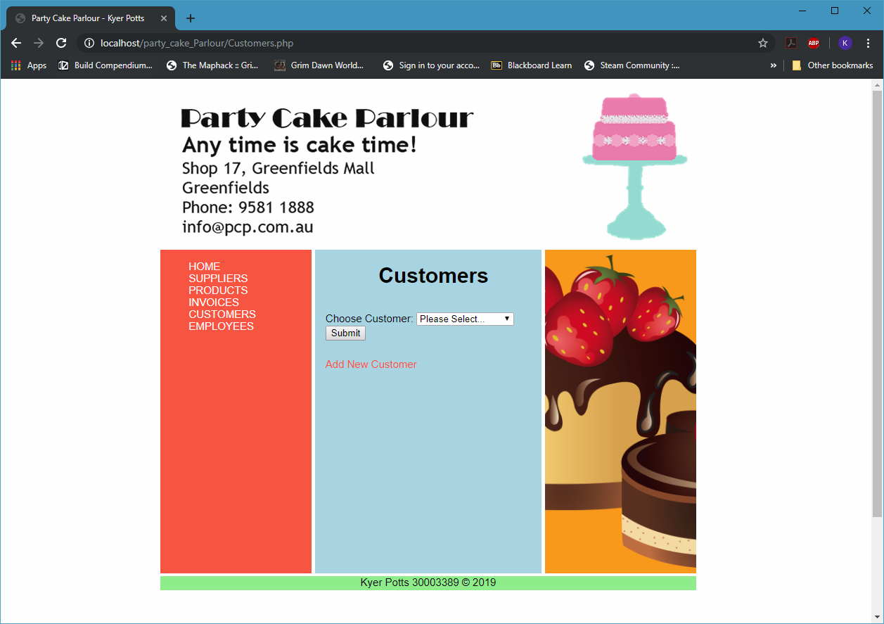

## Screenshot 5.2

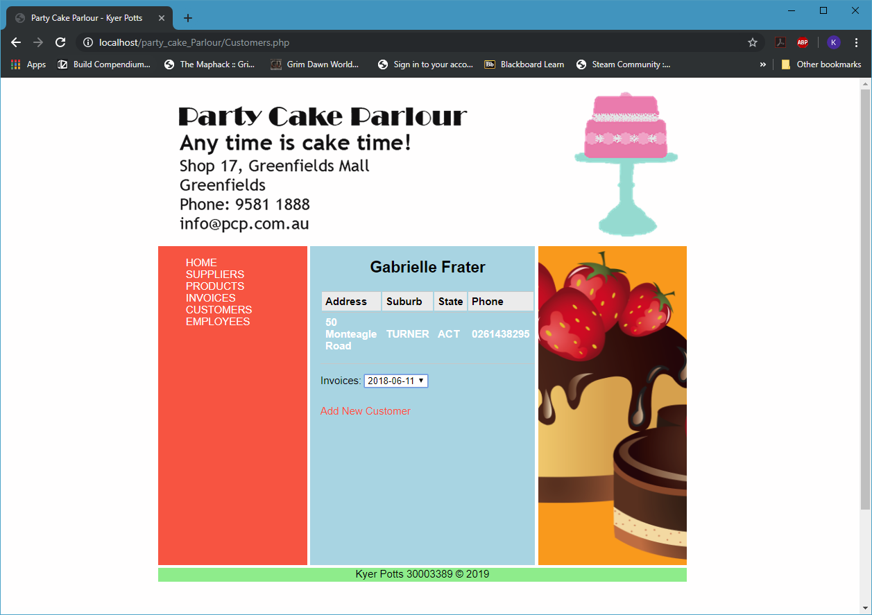

## Screenshot 5.3

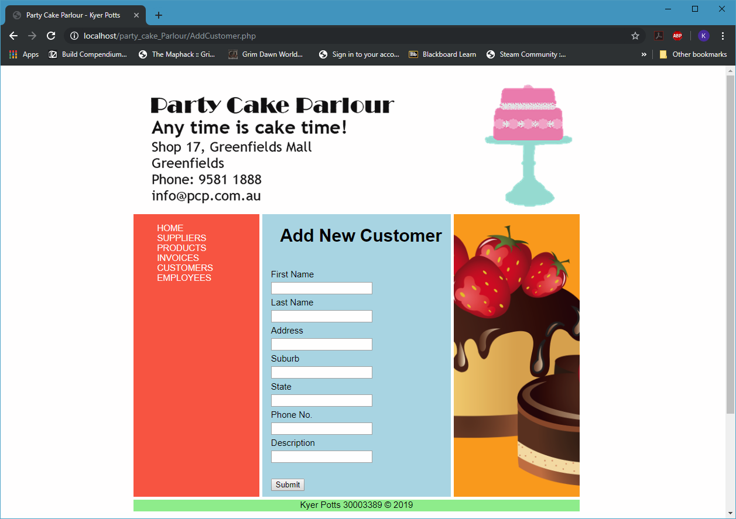

## Screenshot 5.4

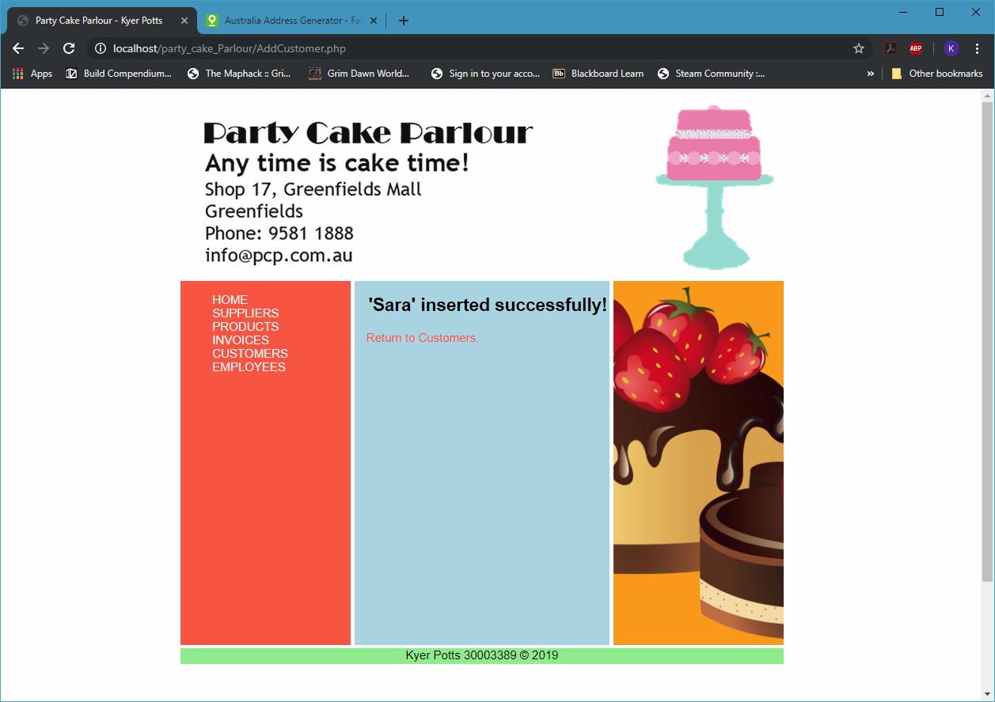

## Screenshot 6.1

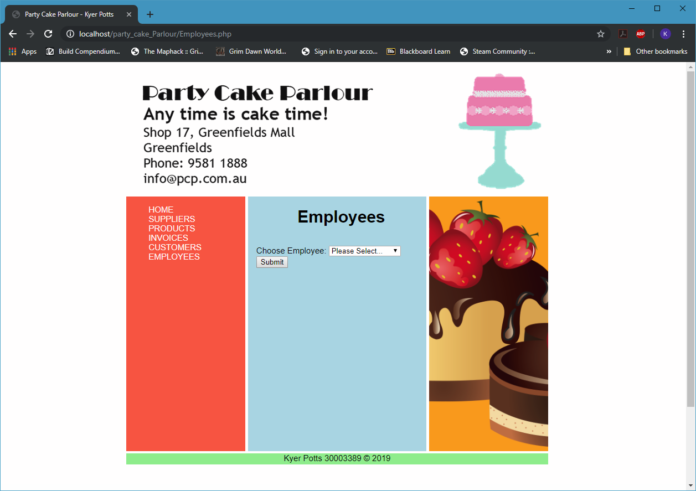

## Screenshot 6.2

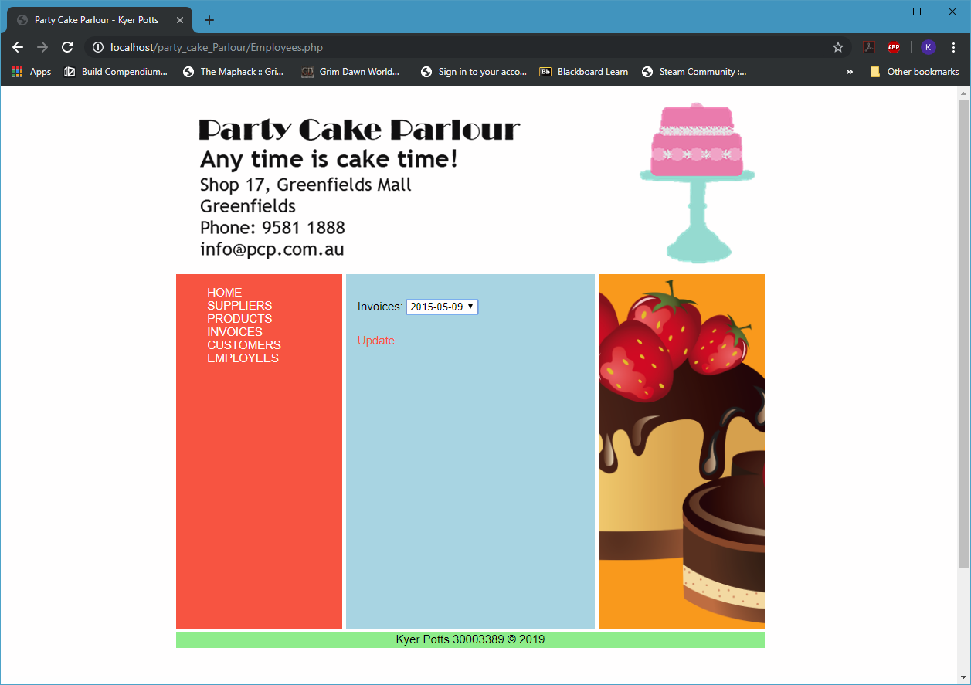

## Screenshot 6.3

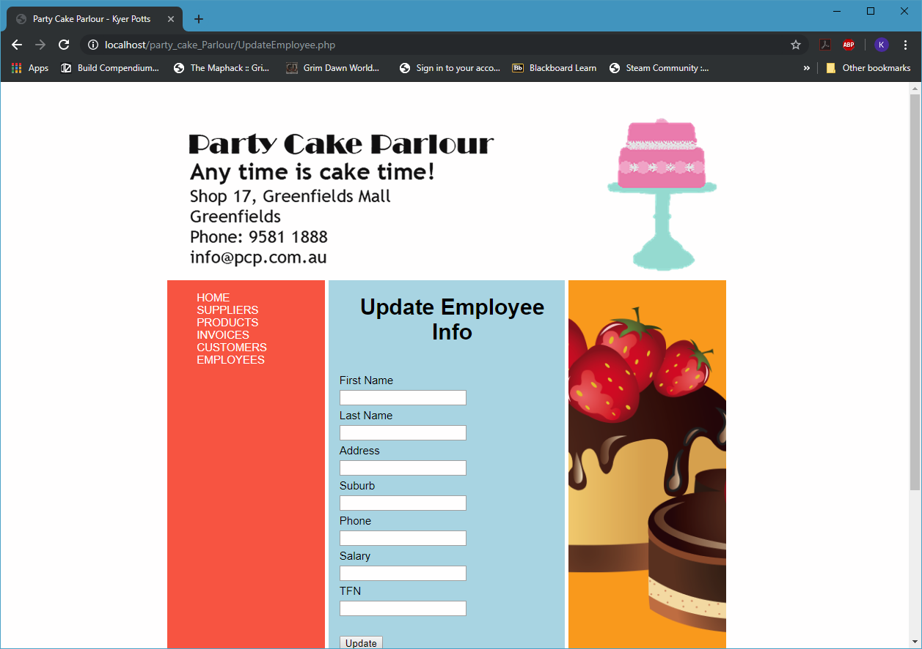

# Security

To prevent error messages from being displayed to the public, configure the php.ini file and set display_errors = Off. This should ensure that all errors are recorded by the log but will not appear on the browser.

To minimise potential database attacks such as SQL injection, make sure that all input is validated, and that the code never uses the input directly. Turning off all database errors within production also helps to prevent malicious SQL injection into the database.

# Recommendations

The application handles invalid data input y implementing form validation.

There are two main types of form validation; client-side and server-side form validation. Client-side validation occurs in the web browser, before input is sent to the server, and vice versa for server-side form validation.

When the application cannot connect correctly to the database, error messages are displayed informing the user that the connection is invalid. If this occurs, the user must ensure that all database server connection details have been input correctly and must retry the connection.

If a direct server connection cannot be managed, alternative strategies must be sought in the form of offline capability. This can be achieved by requesting intermittent data dumps, or providing default static pages with messages and data handling functionality.